3)
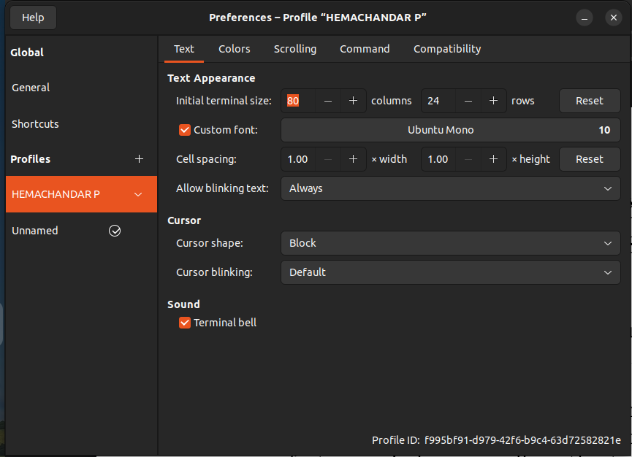
UBUNTU SANS MANO ,SIZE 10

DARK BACKGROUND
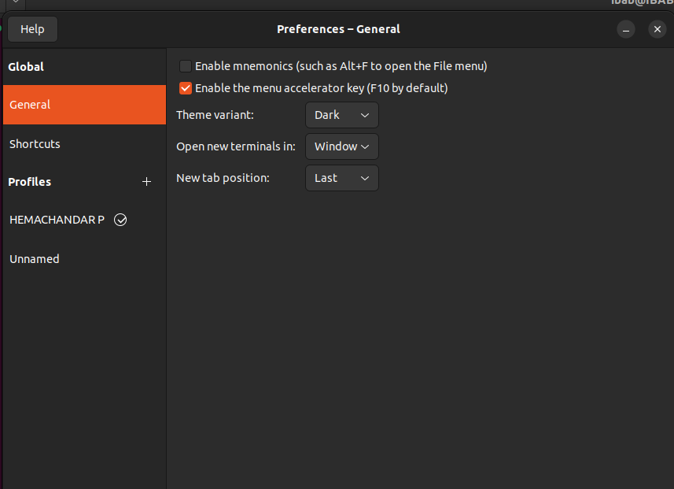

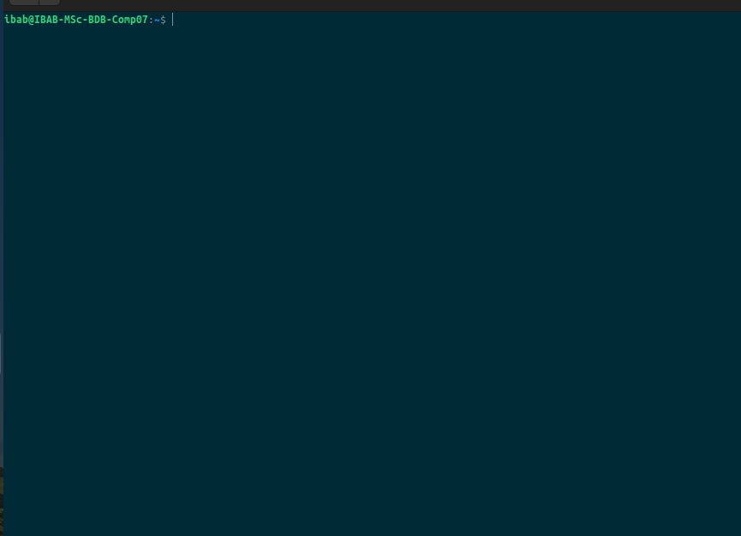

I BEAN CURSOR SHAPE,ENABLE CURSOR BLINKING,DISABLED TERMINAL BELL

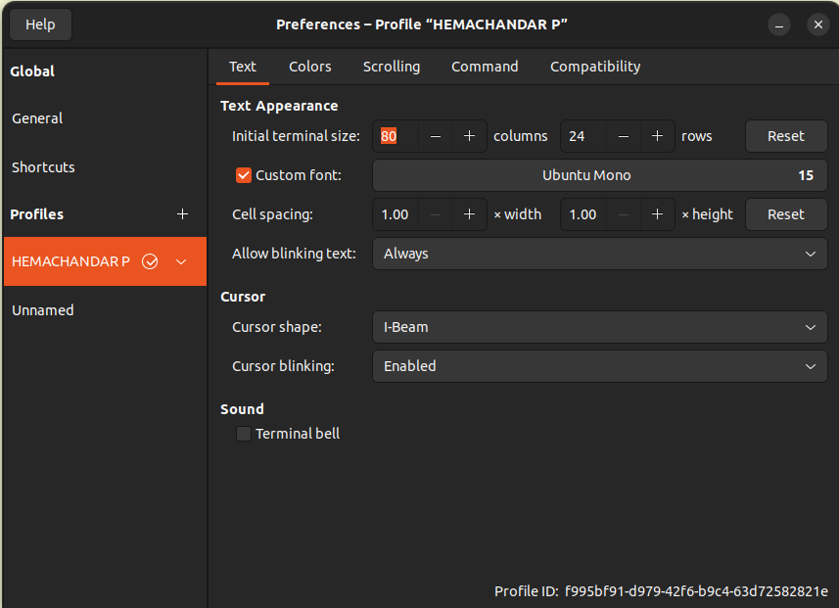

COLOR PALTTE ENTRY 9
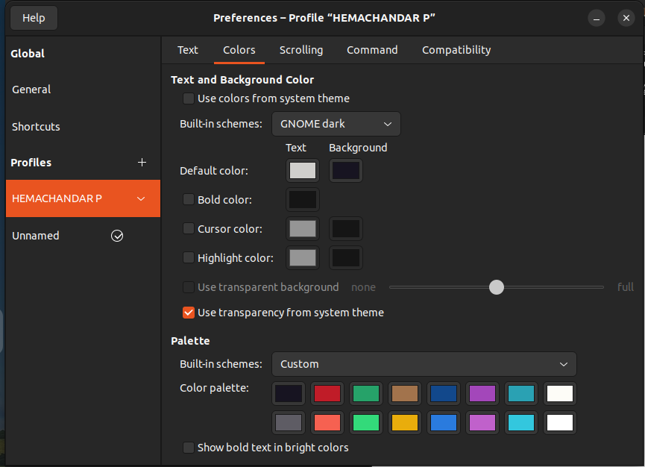

4)MyTestPrompt1=””
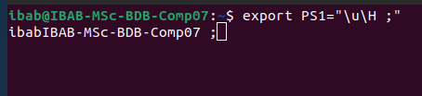
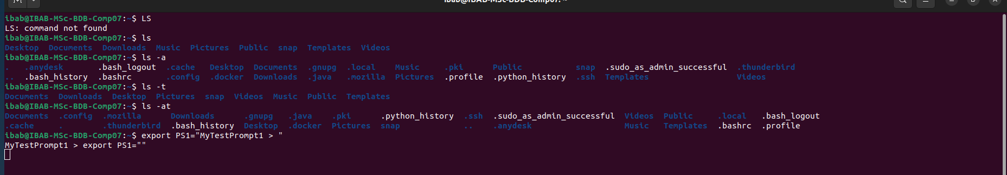

5)USERNAME,HOSTNAME AND MAKE THE TIME FORMAT FOR 24 HOURS

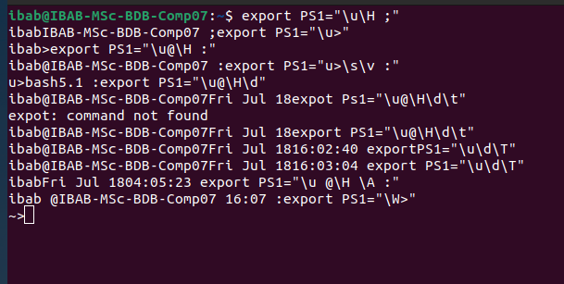

6)HOSTNAME AND MAKE THE TIME FORMAT FOR 12 HOURS

7)COLOR OF MY COMMAND PROMPT TO HAVE BOLD , UNDERLINE AND BLUE APPEARANCE

